University of Bahrain

College of Information Technology

Department of Computer Science

ITCS389 – Software Engineering I

**Online Shopping System**

**Team Members:**

**Hajer Khalifa Ahmed 202004290 (section 1)**

**Asma Khalifa Ahmed 202004165 (section 1)**

**Fatima Mohamed Abdulla 202004322 (section 2)**

Table of Contents

**Phase I: Project Management 3**

**1.1 Introduction to Online Shopping Systems 3**

**What is Online Shopping? 3**

**1.2 Background 5**

**1.2.1 Client's Business 5**

**1.2.2 Existing System 5**

**1.2.3 Business Goals 5**

**1.3 Problem Definition 6**

**1.3.1 Specific Issues 6**

**1.3.2 Impact Analysis 7**

**1.3.3 Desired Outcomes 7**

**1.4 Project Objectives 8**

**1.4.1 Measurable Goals 8**

**1.4.2 Alignment with Business Goals 8**

**1.5 Process Model: 8**

**1.5.1 Model Selection: 8**

**1.5.2 Model Description: 9**

**1.5.3 Visual Representation: 9**

**1.5.4 Justification: 12**

**Conclusion: 12**

**Phase 2: System Analysis Document………………………………………………………….….…13**

**2.1 Requirements Collection………………………………………………………………….……..13**

**2.2 Functional requirements………………………………………………...………………………16**

**2.3 Non- functional requirements………………..…………………………………………………16**

**Phase I: Project Management**

**1.1 Introduction to Online Shopping Systems**

Online shopping is the process of buying goods or services over the internet, using websites or apps. It has transformed the way we shop, making it easier and more convenient.

**What is Online Shopping?**

At its core, online shopping allows customers to browse products, read reviews, and make purchases from anywhere, without stepping into a physical store. Users can fill their digital shopping carts and complete transactions securely.

**Aims of Online Shopping**

1. **Convenience**: Shop anytime, anywhere, without the need to travel.
2. **Variety**: Access a broader range of products and brands.
3. **Accessibility**: Reach customers in remote areas or with mobility challenges.
4. **Cost-effectiveness**: Often lower prices and exclusive online deals.
5. **Enhanced Experience**: Personalized recommendations and easy returns.

In short, online shopping aims to make purchasing simpler, more efficient, and enjoyable for everyone.

**Key Features:**

**User Registration and Profiles:** Users can create accounts to save preferences, track orders, and manage personal information.

**Product Catalog:** A dynamic catalog showcasing products with filters for categories, prices, and ratings.

**Shopping Cart**: Users can add or remove items, view total prices, and proceed to checkout.

**Secure Payment Processing:** Integration with payment gateways (e.g., PayPal, MasterCard) to ensure safe transactions.

**Order Management:** Users can view order history, track shipments, and request returns.

**Customer Support**: Live chat and FAQ sections to assist users with inquiries.

**Admin Dashboard:** For merchants to manage inventory, process orders, and analyze sales data.

**Objectives:**

**Enhance User Experience:** Create an intuitive and engaging interface that encourages users to explore products.

**Improve Security:** Implement best practices in data encryption and secure payment processing to protect user information.

**Increase Sales Efficiency:** Optimize the checkout process to reduce cart abandonment rates.

**Enable Scalability:** Design the system to easily accommodate an increasing number of users and products.

**Provide Analytics:** Equip merchants with insights into customer behavior, sales trends, and inventory management.

**Client/Organization**

**Trend Nest** is a growing e-commerce company specializing in fashion and lifestyle products. The organization seeks to enhance its online shopping capabilities to compete more effectively in the digital marketplace. The project aligns with their strategic goal of improving customer engagement and increasing sales through an upgraded online platform.

**Stakeholders**

**Project Sponsors:**

. CEO: Provides overall vision and direction for the project

CTO: Oversees the technical implementation and ensures alignment with the company’s technology strategy

**: End-Users**

Consumers: Individuals seeking to purchase products online.

Frequent Shoppers: Users who value a personalized shopping experience and loyalty rewards.

**Technical Team Members:**

Project Manager: Manages timelines, budgets, and team coordination.

Front-End Developers: Responsible for designing the user interface and ensuring responsiveness across devices.

Back-End Developers: Handle server-side logic, database management, and API integrations.

UI/UX Designers: Create wireframes and prototypes to enhance user interaction

Quality Assurance Engineers: Conduct testing to ensure the system functions correctly and meets user expectations.

**: Marketing Team**

Digital Marketers: Develop strategies to promote the online shopping system and attract users.

Content Creators: Generate product descriptions, blog posts, and promotional materials to enhance SEO and engagement.

**: Customer Support Team**

Support Agents: Assist users with inquiries, complaints, and technical issues, ensuring high customer satisfaction.

**Additional Considerations**

Compliance: Ensure the platform adheres to data protection regulations (e.g., GDPR, CCPA) and commerce laws.

User Feedback: Implement mechanisms for collecting user feedback to continuously improve the system.

**Accessibility:** Design the platform to be accessible to users with disabilities, following WCAG guidelines.

**1.2 Background**

**1.2.1 Client's Business**

The client operates an online shopping platform, offering a wide range of products to a global audience. Their focus is on providing a seamless shopping experience for diverse consumer needs, including electronics, fashion, and household items. They cater to both individual customers and small businesses

**1.2.2 Existing System**

The current system manages product listings, orders, and customer interactions but faces challenges in handling increased traffic and inventory updates. Manual processes slow down order fulfillment and customer support. The platform lacks advanced analytics to track user behaviors and optimize marketing. Security measures also need improvement to protect sensitive customer data.

**1.2.3 Business Goals**

The client aims to enhance operational efficiency by automating inventory management and order processing. They seek to improve the customer experience through personalized recommendations and faster response times. Expanding their market reach while ensuring robust security measures is a key focus. Additionally, the client wants to integrate advanced analytics for data-driven decision-making.

**1.3 Problem Definition**

**1.3.1 Specific Issues**

**1- User Experience Challenges:**

Navigation Difficulties: Users struggle to find products due to a poorly structured navigation menu and ineffective search functionality, resulting in frustration and abandonment.

Mobile Responsiveness: The current platform does not perform well on mobile devices, which is a significant drawback given the increasing number of users shopping via smartphones.

Checkout Process Complexity: Complicated checkout procedures with too many steps can deter customers from completing their purchases.

**2-Security Concerns:**

Data Vulnerabilities: The existing system lacks modern encryption methods and secure payment gateways, leaving sensitive customer data exposed to potential breaches.

Fraudulent Activities: The absence of robust fraud detection mechanisms increases the risk of unauthorized transactions, leading to financial losses for both the company and its customers.

**3-Inefficient Order Management:**

Inventory Tracking: Merchants struggle to maintain accurate inventory levels, leading to stockouts or overstock situations that affect sales and customer satisfaction.

Delayed Fulfillment: Inefficient order processing systems can result in delays in order fulfillment and shipping, which negatively impacts the customer experience.

**4-Limited Customer Engagement:**

Lack of Personalization: The current system does not utilize customer data effectively to provide personalized shopping experiences or product recommendations.

Weak Loyalty Programs: Existing loyalty programs may not be attractive or well-integrated, failing to incentivize repeat purchases.

**5-Inadequate Analytics**

Insufficient Insights: Merchants do not have access to detailed analytics regarding customer behavior, sales trends, and product performance, hindering their ability to make informed decisions.

Limited Marketing Effectiveness: Without actionable data, marketing campaigns lack targeting precision, resulting in wasted resources and missed opportunities.

**1.3.2 Impact Analysis**

**Revenue Loss**

High Bounce Rates: A cluttered interface and poor navigation can lead to a 30-50% increase in bounce rates, directly reducing potential sales.

Cart Abandonment: Studies show that nearly 70% of online shopping carts are abandoned. Streamlining the checkout process could recover a significant portion of lost sales.

**Brand Reputation**

Customer Trust: Data breaches can lead to negative publicity, eroding customer trust and loyalty. A single breach can diminish a brand's reputation for years.

Customer Satisfaction: Poor user experiences can lead to negative reviews and a decreased likelihood of referrals.

**Operational Costs**

Error Rates: Inefficient order management can lead to higher error rates (e.g., sending the wrong items), resulting in increased returns and customer service costs.

Wasted Resources: Lack of inventory management can lead to overstocking and wastage, increasing holding costs.

**Missed Opportunities**

Marketing ROI: Without effective analytics, marketing efforts may fail to reach the right audience, lowering the return on investment.

Customer Retention: Failure to engage customers through personalized experiences can result in high churn rates, reducing lifetime customer value.

**1.3.3 Desired Outcomes**

**1-Enhanced User Experience**

Intuitive Navigation: Design a streamlined navigation system that makes it easy for users to find products.

Responsive Design: Ensure that the platform provides an optimal shopping experience across all devices, particularly mobile.

Simplified Checkout: Implement a one-page checkout process to minimize steps and encourage completion.

**-Improved Security2**

Advanced Encryption: Utilize end-to-end encryption and secure payment gateways to protect user data and transactions.

Fraud Detection: Integrate AI-driven fraud detection systems to identify and prevent suspicious activities in real-time.

**-Efficient Order Management 3**

Real-Time Inventory Tracking: Implement systems that provide real-time updates on inventory levels to prevent stockouts and overstock situations.

Automated Fulfillment: Streamline the order processing workflow to reduce fulfillment times and enhance customer satisfaction.

**4-Increased Customer Engagement**

Personalized Shopping Experience: Use data analytics to provide tailored product recommendations and targeted marketing efforts based on user behavior.

Attractive Loyalty Programs: Develop a loyalty program that rewards customers for repeat purchases and referrals, fostering long-term relationships.

**5-Actionable Analytics**

Comprehensive Reporting Tools: Provide merchants with dashboards that display key metrics, allowing them to monitor performance and make data-driven decisions.

Segmentation Capabilities: Enable merchants to segment customers based on behavior, preferences, and demographics for more effective marketing strategies.

**1.4 Project Objectives**

**1.4.1 Measurable Goals**

The project aims to increase customer satisfaction by reducing order processing time by 30% within the next six months. Another goal is to improve the site’s performance to handle 20% more traffic without delays. We’ll also focus on boosting conversion rates by 15% through personalized product recommendations and improving inventory accuracy by integrating real-time updates.

**1.4.2 Alignment with Business Goals**

These objectives align directly with the business’s need to enhance customer experience, improve efficiency, and support growth. By optimizing order handling and site performance, the project will help the client reach more customers, streamline operations, and ultimately increase revenue. The focus on real-time data will support better decision-making.

**1.5 Process Model:**

**1.5.1 Model Selection**:

We have chosen the V-Model for the Online Shopping System project because of its structured approach to development and testing. The V-Model emphasizes verification and validation at each stage, ensuring that each component is thoroughly tested before progressing. This is crucial for an online shopping system, where functionality and user satisfaction are essential. Additionally, its strong focus on documentation supports better stakeholder communication and helps maintain quality throughout the project.

**1.5.2 Model Description:**

The V-Model is a straightforward approach to software development that connects each step of building the system with a testing step. Here are the main phases:

1 - Requirements Analysis: We start by gathering what the system needs to do based on input from users and stakeholders.

2 - System Design: Next, we plan how the system will work, deciding how different parts will fit together.

3 - Detailed Design: This phase breaks down the system design into specific details for each part or module.

4 - Implementation: Here, developers write the actual code to build the system according to the detailed designs.

5 - Unit Testing: After coding, each part is tested separately to make sure it works correctly.

6 - Integration Testing: Once the parts are tested, we combine them and check if they work well.

7 - System Testing: In this phase, we test the complete system to ensure it meets all the requirements and works as expected.

8 - Acceptance Testing: Finally, we perform acceptance testing to confirm that the system is ready for users and meets their needs.

**Roles and Responsibilities:**

**Key roles include the Project Manager, who coordinates the project; the Business Analyst, who gathers and explains the requirements; Developers, who write the code; and Testers, who check that everything works properly.**

**Artifacts:**

Important documents in the V-Model include the Requirements Document, which lists what the system should do, the Design Specifications, which shows how the system is set up, and various Test Plans that outline how we will test each part of the system. These documents help keep the project organized and ensure everyone is on the same page.

**1.5.3 Visual Representation:**

We will use the Gantt diagram (Team Gantt) due to its simplicity in presenting tasks, it shows horizontal bars representing **task durations**, the benefits of using the Gantt chart are:

1. Show task durations.
2. Show time overlap.
3. Show slack time in duration.

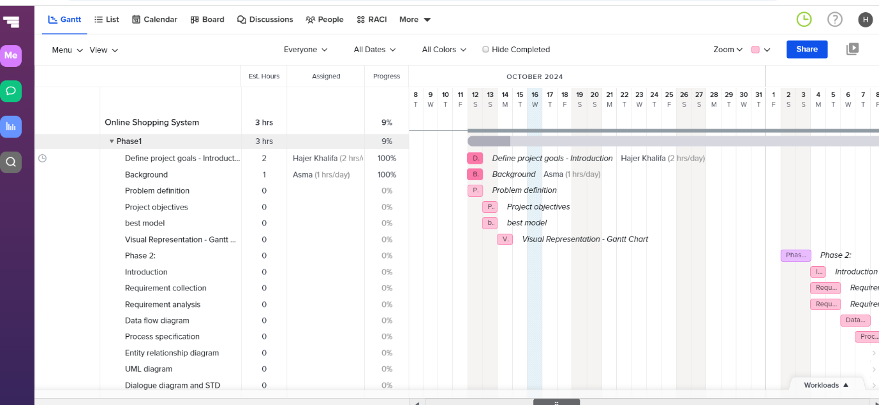

The Gantt chart not only delineates project timelines but also tracks individual progress. For instance, when Hajer initiates a task but is unable to complete it, she can document her advancement by indicating a percentage of completion. If she has accomplished half of the task, she can utilize the progress tool to designate her work as 50% complete. This visibility allows her colleagues, such as Asma and Fatima, to recognize that the task remains unfinished and enables them to step in and contribute as needed. Consequently, the entire team benefits from a clear and accessible overview of each member's progress.

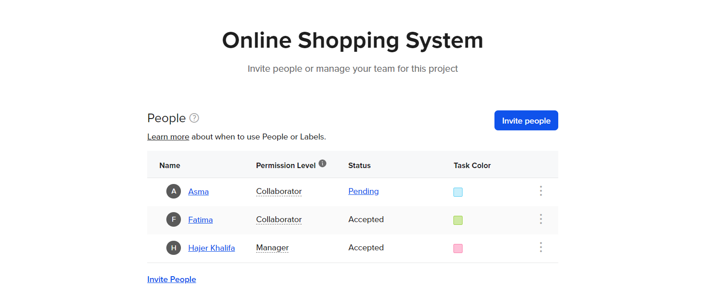

Also, it allows us to add or invite new colleagues who working on this project.

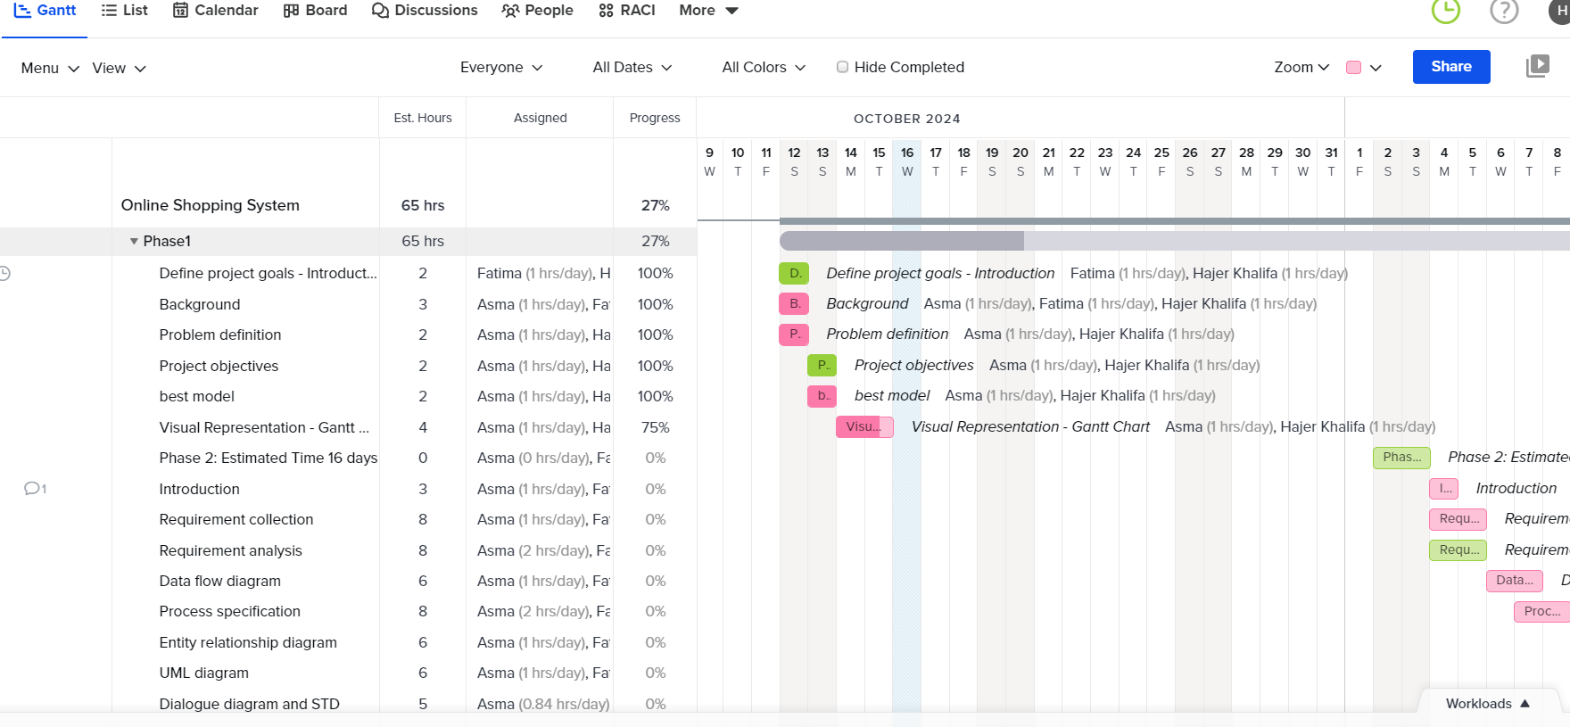

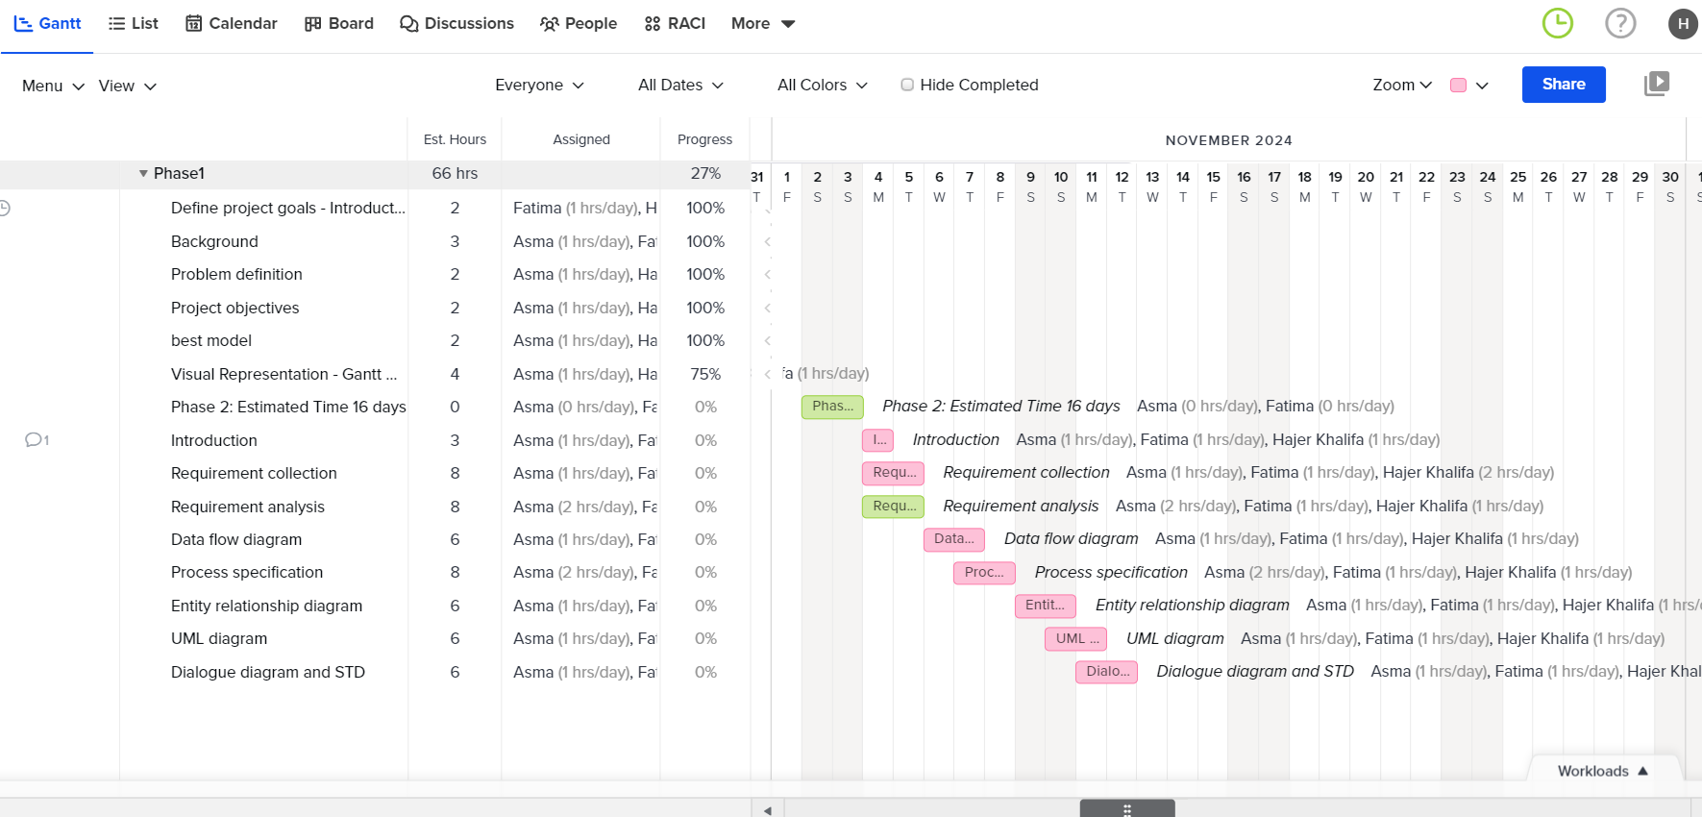

As project managers, it is imperative that we allocate specific time each day to advance particular tasks, dedicating a minimum of one hour daily to this effort. Consistent daily engagement is essential, and we must actively monitor each other's progress on every task to identify any impediments and track outstanding assignments. This collaborative oversight ensures that we remain aligned and accountable throughout the project lifecycle.

**1.5.4 Justification:**

We chose the Gantt diagram for many reasons, which we will list in the below table

|  |  |
| --- | --- |
| **Visual Clarity**: Gantt charts provide a clear visual representation of project timelines, making it easy to see the start and end dates of tasks immediately | 1 |
| **Task Relationships**: They show dependencies between tasks, helping teams understand how one task impacts another and ensuring proper sequencing. | 2 |
| **Progress Tracking**: Gantt charts allow for easy tracking of task completion, making it simple to assess overall project progress and identify delays. | 3 |
| **Resource Management**: By visualizing tasks along a timeline, project managers can better allocate resources and identify potential bottlenecks. | 4 |
| **Communication Tool**: Gantt charts serve as an effective communication tool for stakeholders, providing a straightforward overview of the project status. | 5 |
| **Flexibility**: They can be easily updated to reflect changes in the project schedule, helping teams adapt to shifting timelines. | 6 |

**Conclusion:**

Gantt diagrams are special because they provide a straightforward visual representation of project timelines, making it easy to grasp the sequence and duration of tasks at a glance. Their ability to highlight task dependencies helps teams understand how delays in one area can affect the overall project. This clarity fosters better communication among team members and stakeholders, as everyone can see progress and identify potential bottlenecks. Moreover, Gantt charts are adaptable; they can be updated quickly to reflect changes, which is essential in the dynamic world of project management. Overall, their blend of simplicity and functionality makes them an invaluable tool for keeping projects on track.

**Phase 2: System Analysis Document:**

**2.1 Requirements Collection:**

We used different ways to collect our project requirements, as requirements analysis is figuring out what people need and expect from a new product. We will list them in detail:

|  |  |
| --- | --- |
| Description: | Methods used to collect the requirements: |
| Initially, we interviewed individuals because it was hard to find time to meet with everyone together. | Interviewing individual |
| We scheduled meetings to meet at least twice a week. Later, we started meeting daily because the project needed constant review and focus. Meeting together helped us discuss and prepare our questions simultaneously, which was efficient. | Interviewing groups |
| We used the observation method by closely watching how students interacted with the product. This helped us understand their needs and preferences, which informed our design decisions | Observation |
| We prepared a checklist and an agenda to clarify our requirements and needs. This helped us stay organized and make the most of our discussion time | Preparing a checklist |

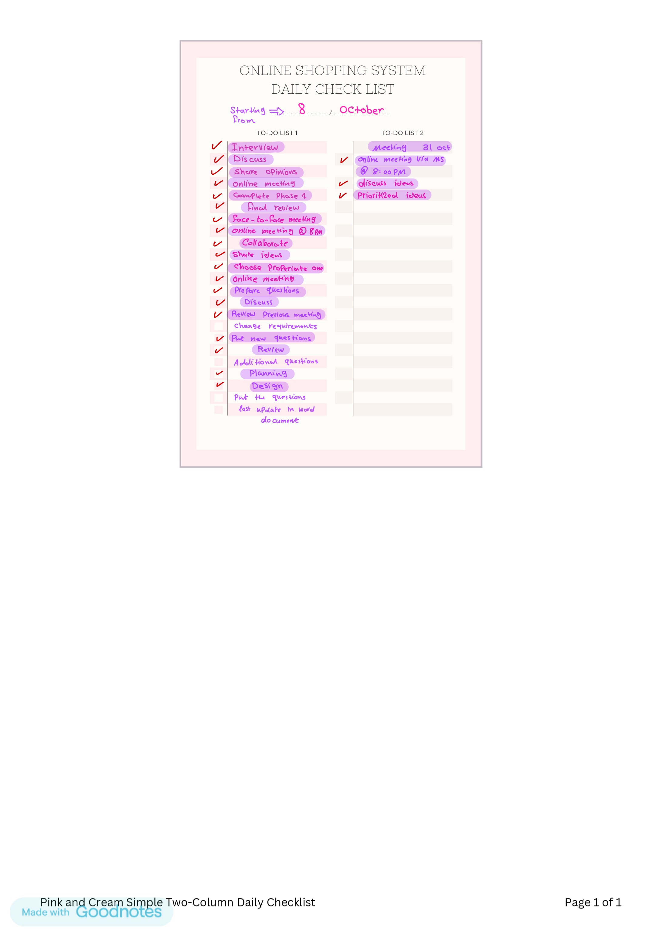

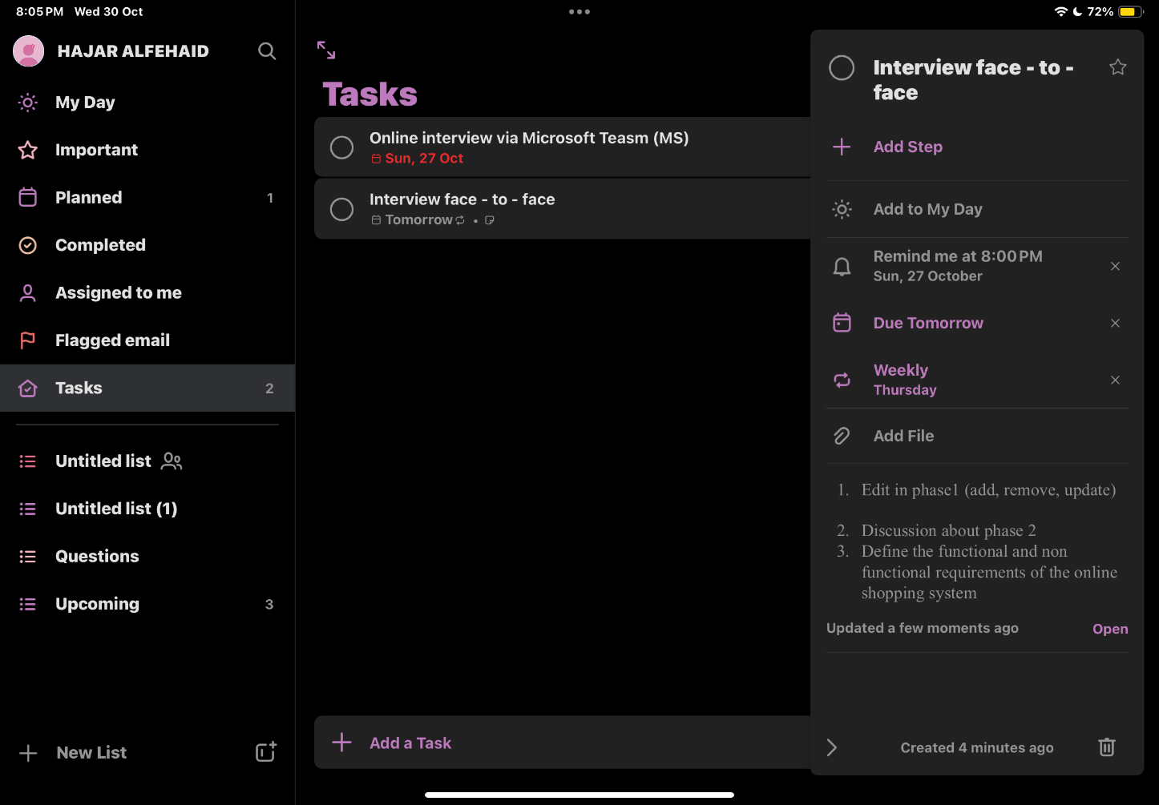

Daily repetition

Regarding interview questions:

We met with **experts** in this field, and we collected a lot of information. We met on Saturday, November 2, because it was a holiday, and the timing worked for everyone. However, we decided to hold in-person meetings on Saturdays, while the rest of the week would be online via Microsoft Teams.

|  |  |
| --- | --- |
| Answers: | Questions: |
| The main purpose is to allow customers to browse and purchase products online. | What is the main purpose of the online shopping system? |
| Important features include easy navigation, secure payment options, and order tracking. | What features are most important for users? |
| We use encryption and secure payment gateways to protect customer information. | How do you ensure customer data security? |
| Challenges include managing inventory and handling customer service inquiries. | What challenges do you face with the system? |
| We gather feedback through surveys and reviews on the website. | How do you gather user feedback? |
| **Customers**: Users who purchase products from the online shopping system.  **Service Providers**: Companies that handle logistics, payment processing, and delivery.  **Admins**: Individuals responsible for managing the online platform, overseeing operations, and ensuring everything runs smoothly. | Who are the main stakeholders involved? And explain each one of them |

We met in a conference room at The Art Rotana hotel, Amwaj Island. It was a private meeting room, providing a quiet and isolated space for our discussions.

**2.2 Functional requirements:**

**We have plenty of functional requirements (must-have) we will list some of them below with a brief explanation of each one:**

1. **The system must include a shopping cart: that allows the customers to add items they wish to buy.**
2. **The system must provide options to add, remove, or update items in the shopping cart: allowing customers to modify their selection as needed.**
3. **The system must display the price for each item: As well as the total price including taxes and shipping in the shopping cart.**
4. **Each item listed in the system must have a brief description: giving customers essential information about the item/product being offered.**
5. **The system must include the payment process(credit, cash, benefit, Apple pay, ..)**
6. **Order tracking: we can consider it as a functional requirement since it's relates to a user's ability to monitor the status of their purchase.**

**2.3 Non- functional requirements:**

**1. performance: The system should respond quickly, support many users simultaneously, and be capable of expanding as the user base grows, with efficient interaction.**

**2. Security: The system must secure sensitive data to prevent unapproved access and protect customers' data by providing a unique username and new password to be written for each registered user, and also will be more secure if the system provides a verification code.**

**3. Usability: The system should be user-friendly to all users (easy to understand and easy to log in), not complicated steps to be done during registration.**

**4. Reliability: The system should be straightforward to maintain, consistently available, and able to manage errors without failure.**

**5. Compatibility/ Portability: The system should work well across various devices( mobile, iPads, tablets, and desktops), and integrate smoothly with current systems and technologies, also it should support both IOS and Android.**

**6. Availability: The system should be able to stay up and running almost always.**

**2.4 Data Flow Diagrams (DFD) :**

**2.4.1 Context Level DFD:**

**2.4.2 Level 0 DFD:**

**The Level-0 diagram provides a more detailed view than the context diagram. It outlines the primary functions performed by the system, breaking down the high-level processes presented in the context diagram into subprocesses.**

**2.4.3 Level 1 DFD:**

**The Level-1 diagram represents a breakdown of all the processes outlined in the Level-0 diagram, dividing them into two or more subprocesses where applicable.**

**2.5 Process Specification**

**2.5.1 Structured English**

**2.5.2 Decision Tables**

**2.6 Entity-Relationship Diagram (ERD):**

**An entity–relationship model (ER model) is a conceptual framework used to define and document the logical data requirements of a database system. It focuses on the data itself and how different pieces of data relate to one another. The key elements of ER models are entities, which represent objects or concepts, and the relationships that connect these entities.**

